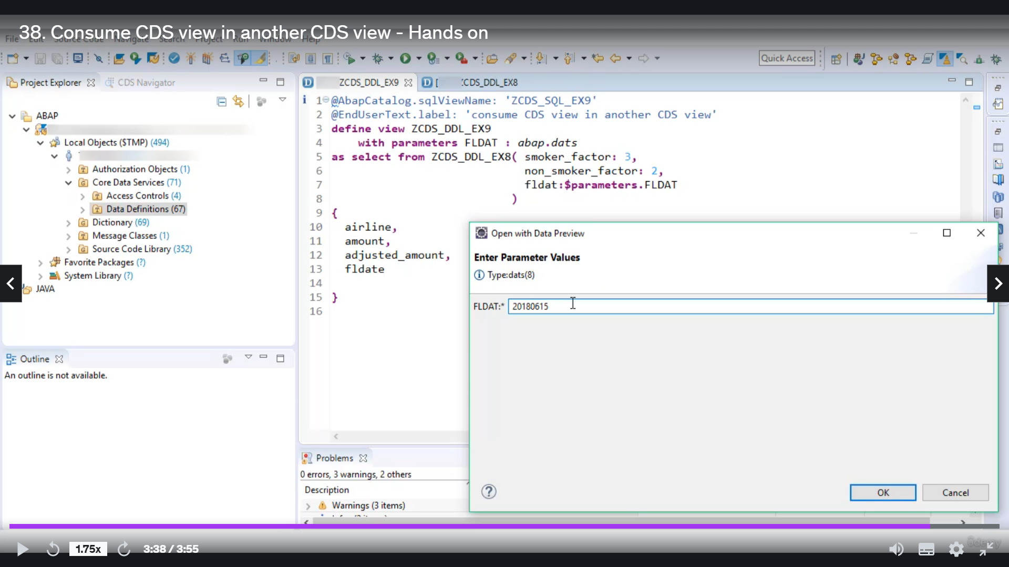

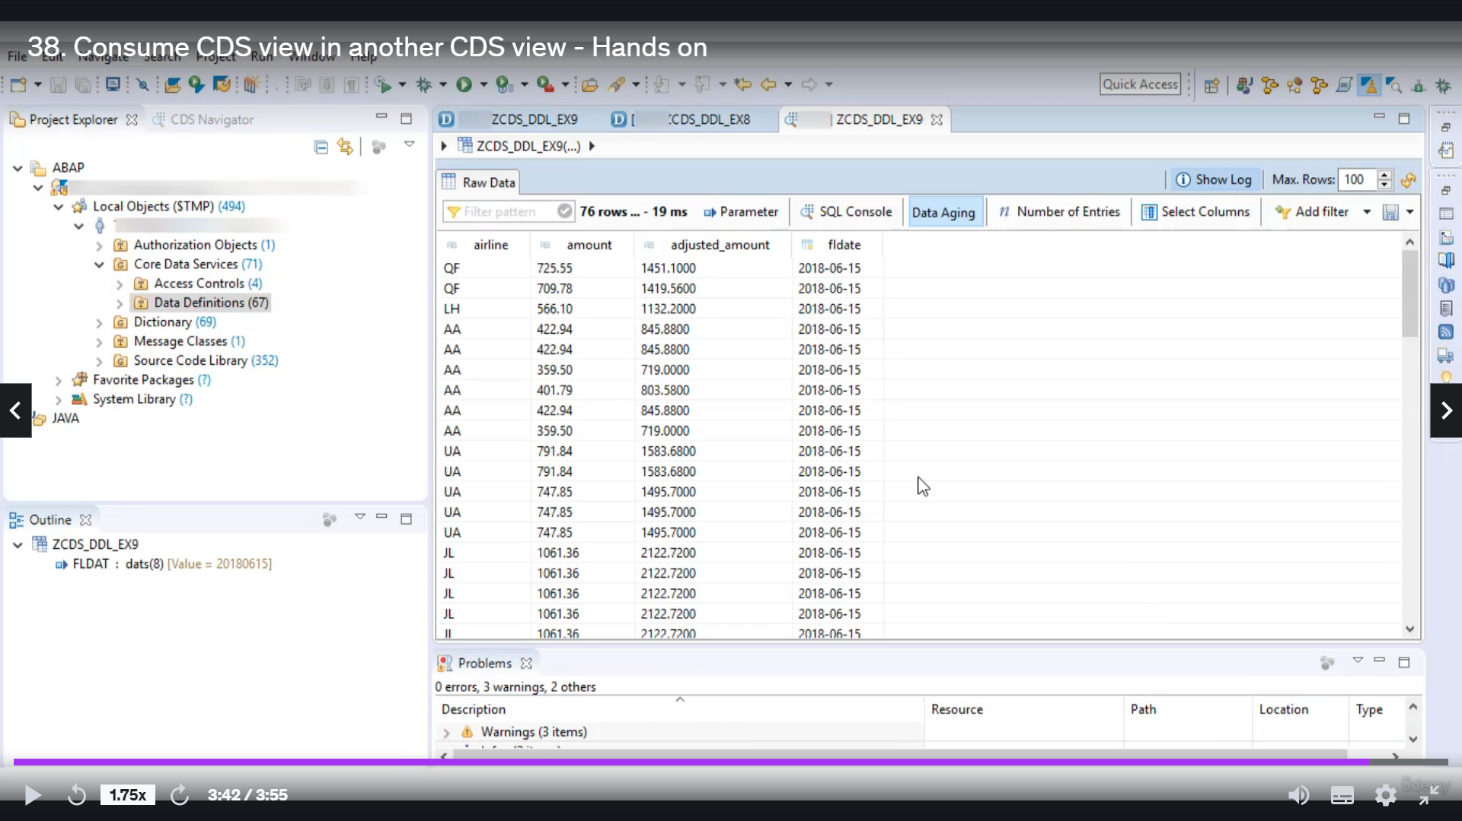

Looks great when I get through this you.

With ninjitsu, this example, nine.

The ESCUCHA.

OK, so let's do the basic setting, I don't record this to an audience, I will remove it.

I will change your screen name as serious as squill example name.

You don't want to consume previously created CDU serious digital example eight.

OK, so now here you have to give Smokler factor, non smoker factor and deflate gate.

So, uh, whatever you do, I will create one input parameter here and that parameter I will get the

input to this parameter.

So let's create one parameter.

You.

Let's give us the barometer types about dog tags and the value to this barometer will pass to this barometer

if we want to shortcode and just press controlled space and take that barometer.

Let me quickly rearing this for better view.

So there are some films which are there in these studios view you.

OK, I will open this series for you, selected issue list of three.

So now you're the first airline account smoker.

I just did a modern flight deck.

So those fools you have to use you.

It just depend on you and how much you want.

I want to use all different I will use.

Always make sure that you are not writing your Garraty because there is no such vulgarity.

In this view of Cariddi you are to use airlines.

So I will write you a line or you can do the counter space.

It will give you all the values airline line amount.

I just amont.

Smoker and it.

So if you don't want to see smoke, you can simply remove.

And.

There is no error, so I will activate and let's on it.

So now you can see things, we are taking this parameter as the input parameter, so it is asking it

to enter value.

And since we are not using here, we are not putting any system face to this parameter.

That's why it becomes mandatory.

So now you can pass that value 2018 in zero six one five.

OK, and here is the output.

I hope you understood how you get consumed once you disappear into another dispute.

Thank you for watching with you.

Have a great day.